**Project Report**

***Political Juggernauts: A Quantitative Analysis of candidates in the 2019 Lok Sabha Elections***

**NM ID: NM2023TMID14823**

**1. INTRODUCTION:**

**1.1 Overview**

The Lok Sabha is composed of representatives of people chosen by direct election on the basis of universal adult suffrages.

**1.2 Purpose**

The constitution of India allows for maximum of 550 members in the house, with 530 members representing the states and 20 representing the union territories.

**2. Problem Definition & Design Thinking**

**2.1 Empathy Map**

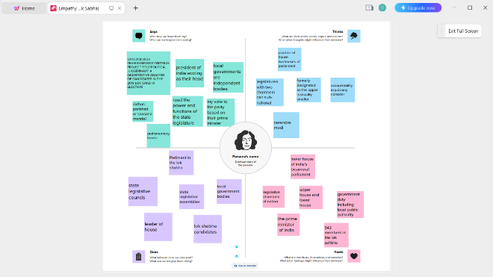

**2.1 Ideation & Brainstorming Map**

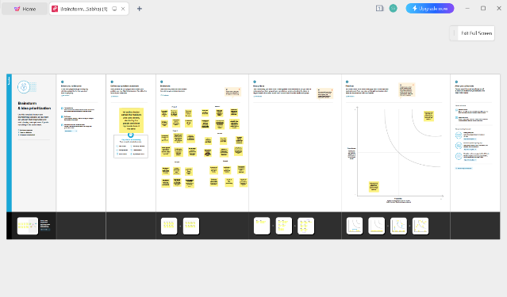

3. RESULT

Dashboard Story

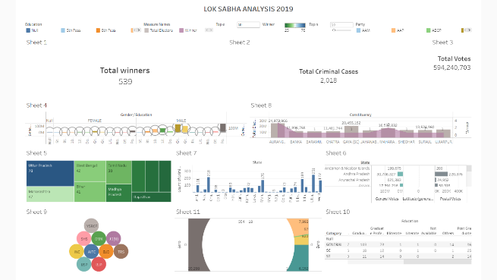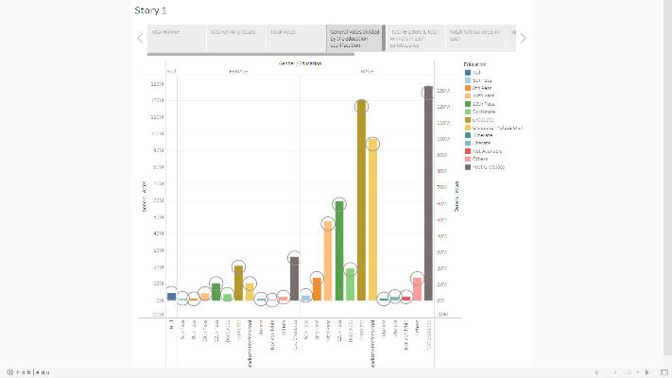

4. ADVANTAGES & DISADVANTAGES

ADVANTAGES:

* It helps in proper functioning of democracy through the system

of checks and balances.

* It contains the members who were directly elected by people and they are considered to the direct representatives of the state.
* Members of parliament of Lok Sabha are chosen by direct elections on the basis of the adult suffrage.
* Article 81 of the constitution of India 1949 has specified the maximum strength of Members of parliament in the Lok Sabha to 552.
* Lok Sabha is the House of Representatives directly elected by the people.

DISADVANTAGES:

* Lok Sabha have limited powers compared to raja Sabha.
* No confidence motion can only be introduced and passed in the Lok Sabha.
* Lok Sabha is based on first-past-the-post electoral system, which can result in a lack of representation for minority parties and groups.
* Members of the Lok Sabha are not always held accountable for their actions, as they are protected by parliamentary immunity.

5. APPLICATIONS:

* Member of Lok Sabha (House of the people) or the lower house of India’s parliament are elected by being voted upon by all adult citizens of India, from a set of candidates who stand in their respective constituencies.
* The house meets in the Lok Sabha Chamber of the Sanad Bhavan in New Delhi, on matters relating to creation of new laws and rules, removing or improving the existing laws that affect all citizens of India.
* Elections take place once in five years to elect 543 members for the Lok Sabha.
* For purpose of constituting the Lok Sabha, the whole country has been divided into 543 parliamentary constituencies, each one of which elects one member.

6. CONCLUSION:

* The election for 543 seats was held in seven phases. Overall around 70 percent polling was recorded in all phases.
* Votes were counted and the result was declared. The election resulted in a landslide victory for the BJP which won 303 seats and formed the government.
* There was seeking re-election from the seat, has registered the highest victory margin in the 2019 Lok Sabha elections
* The Prime Minister and the council of Ministers resign jointly if a majority vote approves the no-confidence Motion.

7. FUTURE SCOPE:

* One of the most important functions of the Lok Sabha is too select the executive.
* The executive is a group of persons who work together to implement the laws made by parliament.
* This executive is often what we have in mind when use term Government
* Music, dance, magic, and witchcraft were also practiced at the ‘Sabha’ along with dicing and gambling.
* The assembly performed administrative and judicial functions,

Exercised its judicial authority, and also discussed pastoral affairs.